STRIKEZONE

TEAM MEMBERS:
- Aisha Naeem(540800)
- Shanzeh Ayub(542888)
- Aiza Azad(547267)

TEAM CONTRIBUTION:
Shanzeh:
- functions and variables initialization
- initialized four-level progression system with escalating difficulty
- Balanced ammunition, time limits, and enemy spawn rates across levels.
- Developed Level 4 unique mechanics (finite drone pool, no respawning)
- Designed all story screens, mission briefings, and menu interfaces
- Implemented console cursor positioning using gotoxy()
- Voiceover

Aisha:
- Team lead and lead developer
- Implemented advanced multi-bullet system with 10 simultaneous projectiles
- Developed complex collision detection algorithm for multiple bullets vs multiple drones
- Created dynamic drone spawning system.
- Added the audio system
- Designed ASCII art representation for player, bullets, and drones.
- Ppt presentation

Aiza:
- Implemented frame-rate control at 30 FPS using Sleep() timing
- Created a system to check level complete or fail
- Created pause menu system with resume/restart/exit functionality
- Created system to take user input
- Designed the main function to call different functions.
- Documentation

OBJECTIVES:
- Develop an engaging console-based shooting game that demonstrates proficiency in C++ programming concepts including arrays, functions, loops, and conditional statements.
- Implement progressing difficulty mechanics through a multi-level system that challenges players with varying ammunition limits, time limits, lives limit and enemy spawn patterns.
- Create an immersive narrative experience by adding storytelling elements with gameplay mechanics to enhance player engagement and motivation.

PROBLEM STATEMENT:
- Programming education often relies on static, non-interactive exercises that fail to maintain student interest and engagement.
.
- Students need practical projects that combine entertainment with technical skill development while working within the limits of console applications.
- There is a need for an engaging project that demonstrates real-time game mechanics, collision detection, and user interaction without requiring external graphics libraries.

SOLUTION STATEMENT:
- Strikezone is a console-based shooting game that teaches core programming principles through practical, engaging gameplay.
- The game utilizes Console API for cursor manipulation and screen control, creating a dynamic visual experience.
- By implementing a four-level game with varying difficulty parameters, the project shows complex design.
- The addition of storytelling provides context, and transforms a technical exercise into an engaging experience.
- The project showcases key game development concepts—collision detection, input handling, and frame-based loops—while using limited ammunition to promote strategic thinking and practical programming skills.
- The modules structure with separate initialization, update, and using functions demonstrates skills and makes the code maintainable for future enhancements.

MODULES:
. MODULE 1: Core Game Engine & Loop Management:

1.1 Speed Manager
- Makes game run at exactly 30 frames per second
- Uses Sleep(33) to wait between each frame
- Keeps game speed same on all computers

1.2 Level Initialization System
- Resets all values when new level begins
- Sets time limit, bullet count, enemy numbers
- Configures difficulty for each of 4 levels

1.3 Victory/Failure Detector
- Checks if player killed enough enemies (WIN)
- Checks if time ran out or bullets empty (LOSE)
- Decides when level ends.

1.4 Main Loop
- Repeats 30 times per second continuously
- Calls all other modules in correct order
- Keeps game running until level ends

MODULE 2: MULTI-ENTITY MANAGEMENT SYSTEM

2.1 Multi Bullet Management system
- Tracks up to 10 bullets at once
- Stores position (X, Y) for each bullet
- Marks which bullets are active/inactive
- Finds empty slots for new bullets

2.2 Dynamic Enemy Spawning Engine
- Spawns 2-5 enemy drones on screen
- Places them in random positions
- Controls how many enemies appear based on level
- Creates new enemies when old ones die

2.3 Drone Lifetime Counter
- Counts down how long each enemy lives
- Level 1: Enemies live 5 seconds (150 frames)
- Level 2-3: Enemies live 3 seconds (90 frames)
- Makes enemies disappear when timer hits zero

2.4 Level 4 Rules
- Level 4 only: Total of 30 enemies ever
- Dead enemies don't come back
- Stops spawning after 30 enemies created
- Makes final level harder

MODULE 3: REAL TIME INPUT AND PLAYER CONTROL

3.1 Input Handler
- Checks if player pressed any key
- Doesn't pause game while checking
- Uses _kbhit() to detect keypresses
- Uses _getch() to read which key

3.2 Boundary Management System
- Stops ship from going off screen
- Left limit: position -1
- Right limit: position width -2
- Keeps player in safe zone

3.3 Pause Menu System
- Activates when player presses ESC
- Shows menu with 3 choices:
  - Resume (continue playing)
  - Restart (try level again)
  - Exit (quit game)

3.4 Shooting Mechanism
- Activates when spacebar pressed
- Creates bullet at ship position
- Finds first empty bullet slot
- Reduces ammo count (if limited)

MODULE 4: COLLISION DETECTION AND COMBAT SYSTEM

4.1 Collision Detection
- Checks if bullet position = enemy position
- Tests all bullets vs all enemies
- Removes both when they collide
- Runs 30 times per second

4.2 Score Tracking
- Adds 100 points per enemy killed
- Counts total enemies destroyed
- Shows progress: "Kills 12/15"
- Tracks player performance.

4.3 Update System
- Moves bullets up screen each frame
- Updates enemy timers
- Removes bullets at top edge
- Keeps everything moving smoothly

4.4 Ammo Tracker
- Counts bullets remaining (Level 3-4)
- Shows "AMMO: 25" on screen
- Prevents shooting when empty
- Causes game over if no bullets left

MODULE 5: Graphics & Display

5.1 Position Placer
- Uses gotoxy(x, y) to place cursor
- Puts text at exact screen locations
- No flickering or jumping
- Windows API function

5.2 Info Bar
- Shows at top of screen:
  - "LEVEL: 1"
  - "SCORE: 500"
  - "KILLS: 12/15"
  - "AMMO: 25" (if limited)
  - "TIME: 18" (seconds left)

5.3 Character Drawer
- Player ship: A
- Enemy drones: O
- Bullets: *
- Aim line: ^
- Uses keyboard letters/symbols

5.4 Screen Manager
- Clears screen: system("cls")
- Hides blinking cursor
- Draws border lines: ====
- Keeps display clean

MODULE 6: Story, Menus & Player Experience

6.1 Story Teller
- Narrates a game story.
- Creates game atmosphere

6.2 Mission Briefer
- Before each level shows:
  - Mission name and number
  - How many enemies to kill
  - Time limit for level
  - Ammunition status
  - Threat level

6.3 Menu Navigation
- Level Complete screen:
  - Shows kills and score
  - Options: Next Level / Exit
- Level Failed screen:
  - Shows what went wrong
  - Options: Restart / Exit
- Victory screen (beat all levels)

6.4 Random Number Generator
- Seeds random number generator
- Uses current time: srand(time(0))
- Makes enemy positions different each game
- Ensures no two games are identical
6.5 Audio Feedback System
- Plays shoot sound when bullet fires
- Plays victory sound when level complete
- Plays defeat sound when level failed
- Uses Windows Multimedia API (winmm.lib)
- Functions: playShootSound(), playWinSound(), playLoseSound()
- Requires .wav files: shoot.wav, win.wav, lose.wav
SCREENSHOTS CONSOLE BASED:

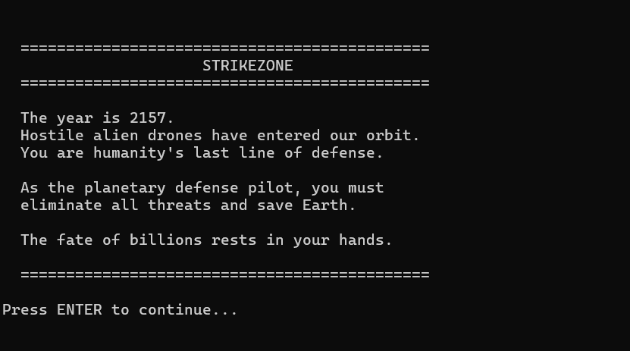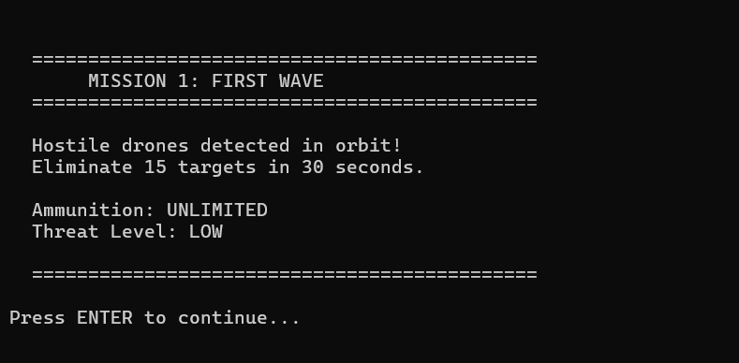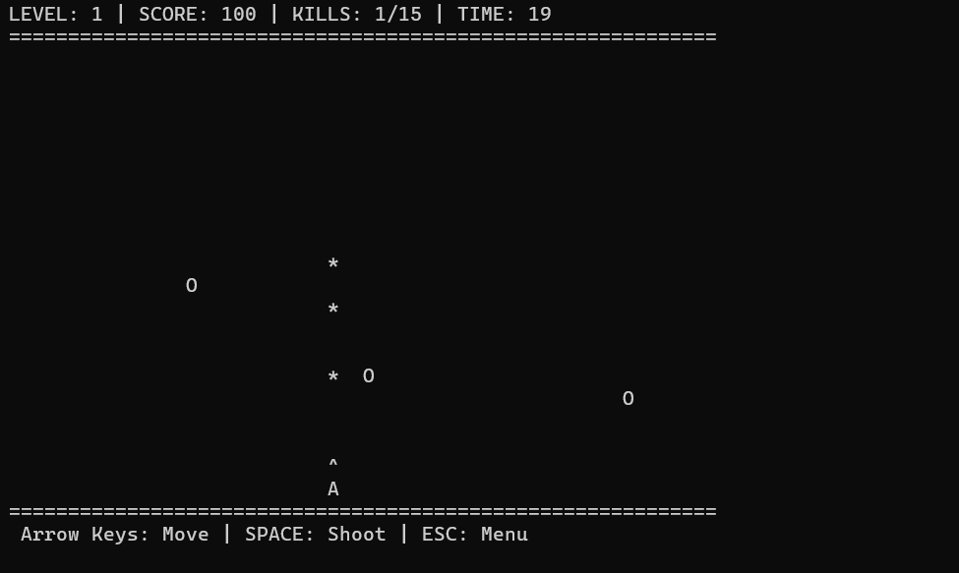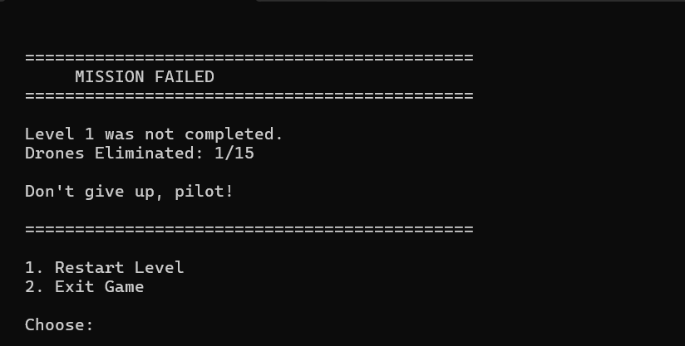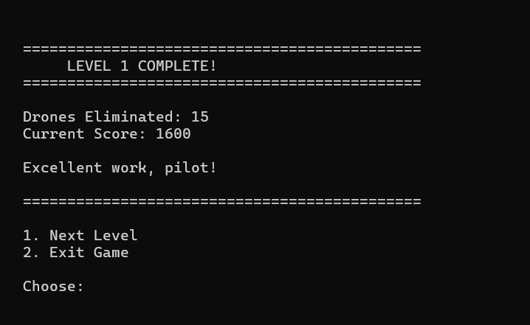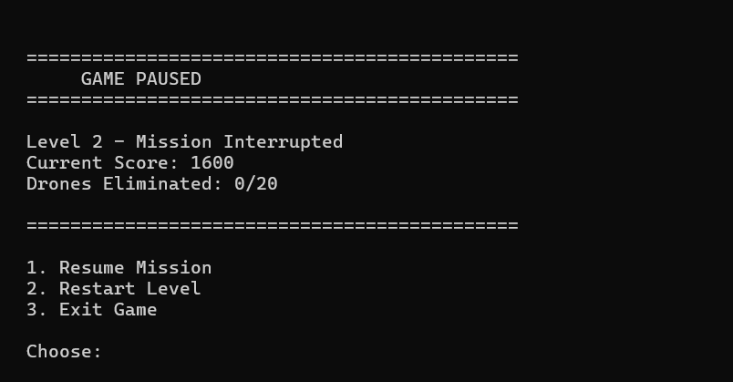

CONCLUSION/OUTCOME:

- Implemented advanced C++ game mechanics including multi-dimensional arrays for multiple bullets and enemies, real-time non-blocking input, collision detection, and stable 30 FPS frame control.
- Designed a four-level progressive difficulty system featuring time limits, limited ammunition, and a final level with a non-respawning enemy pool.
- Applied modular software architecture using six well-structured modules, improving code maintainability, scalability, and clarity.
- Delivered a polished console-based arcade game demonstrating that text-based interfaces can provide smooth animation, responsive controls, and engaging gameplay.

